6YL-100型螺旋榨油机的主要性能参数
主要技术参数：
1、榨轴转速：30-40转/分
2、齿轮箱转动比：15/40*15/55=1：9.78
3、配用动力：7.5KW
4、外型尺寸：长/宽/高（mm)
1640/640/1200
5、单机重量：约480kg
一、工作原理与构造:
1、工作原理:
榨油机运转时,将处理好的料胚带如料斗,油料从料斗进入榨膛。有榨螺的螺旋向里推进，进行压榨。
因料胚在榨油机的榨膛内是在运转状态下进行的，在榨膛高压的条件下，料胚和榨螺，榨膛之间产生很大的摩擦阻力。这样就能使料胚和料胚产生摩擦，造成相对的运动。另一放面，榨螺的根圆直径是逐渐增粗的，当榨螺转动时，螺纹使料胚即能向前推进又能向外翻转，同时靠近榨螺螺纹表面的料层随着榨轴转动，这样在榨膛里的每个料胚微粒都不是等速度同方向的运动。而在微粒之间也存在着相对的运动。有摩擦产生的热量又满足了榨油工艺操作上所必须的一份热量，有助于促使料胚中的蛋白质热变性，破坏了胶体，增加了塑性，同时也降低了油的粘性，容易压榨出油来，因而提高了榨油机的出油率。
1. Oration principle and structure
1.1 oration principle
When oil presses operating prepared material enters extruding chamber from the hopper and then moves forwards by the rotating pressing screw and is pressed. Under the high-pressure condition in the chamber ,friction between material and screw ,between material and chamber will be created ,which also creates friction and relative movement among material particles. On the other hand, root diameter of the pressing screw caries larger from one end to the other ,hence. When rotating ,it not only pushes particles moving forwards but turns them outwards as well ,meanwhile ,particles adjacent the screw will rotation along with screw’ rotating ,causing every particle inside the chamber to possess different speed. Therefore relative movement among particle creates heat which is necessary during manufacturing because of helping protein change property ,damage colloid ,increase plasticity ,decrease oil’s elasticity ,resulting in high oil productivity.

\

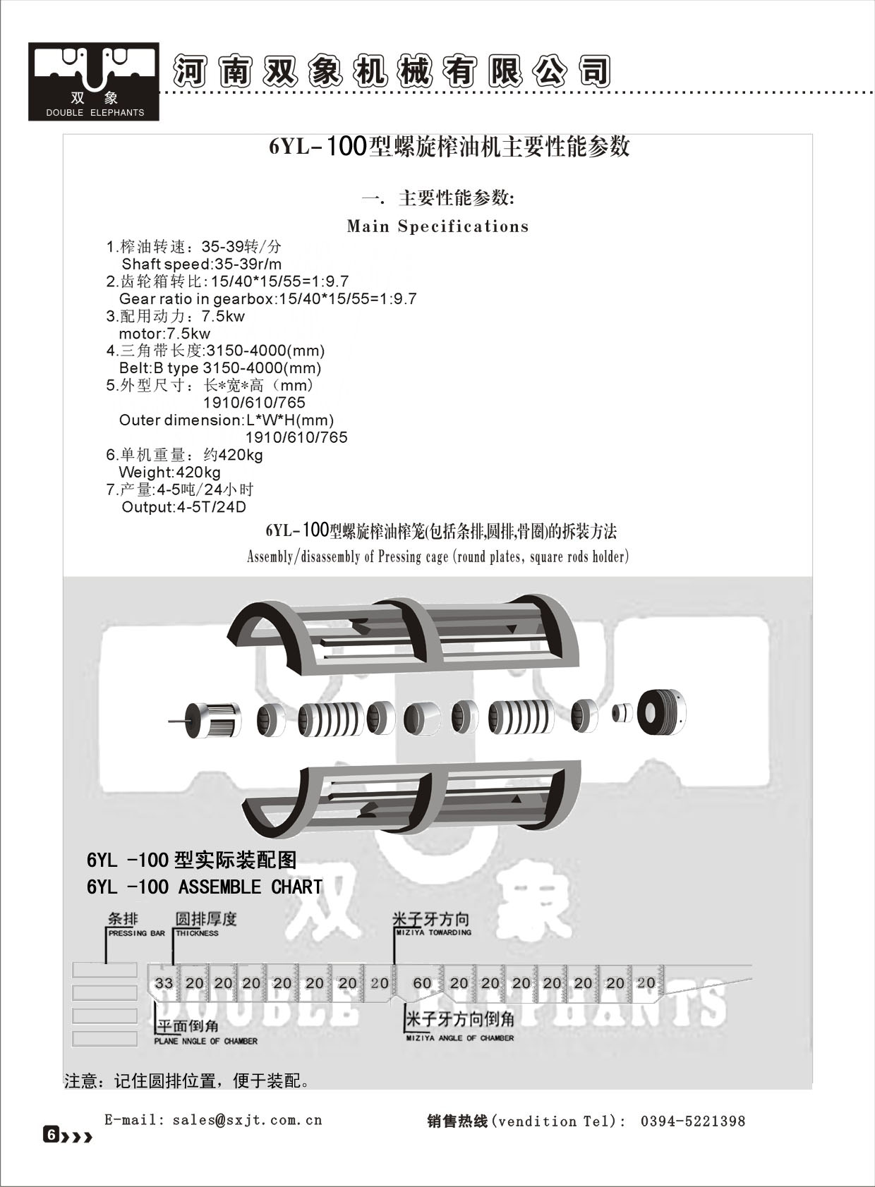

2．结构：该机有进料斗部分，齿轮箱部分，榨膛部分，榨螺部分，机架部分共五大部分组成：见图
（一）

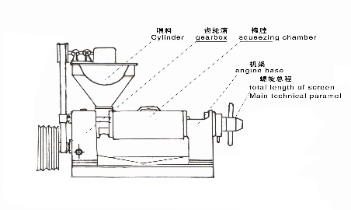
图(一)

二．机器的安装：
榨油机安装时必须在地脚螺栓牢固的安装基础上，使机体保持水平。电机安在进料斗的背面。
2．Installment
The oil press must be installed by bolts firmly on the foundation and be kept horizontal
三．机器的润滑：
1．榨油机主要采用机油和黄油两种形式润滑。加油周期见表二
序号  NO | 润滑部位  lubrication | 油脂种类  lubricate | 加油周期  Time span | 换油周期  Lubricate replacement period
1 | 调节螺栓  Adjusting bolt | 20号机械油  Mechanical oil NO.20 | 每班2次  1-2time/day
2 | 伞齿轮  Bevel gear | 20号机械油  Mechanical oil NO.20 | 每班2次  1-2time/day
3 | 轴承座套  Bearing bush | 20号机械油  Mechanical oil NO.20 | 每班2次  1-2time/day
4 | 齿轮箱  Gearbox | 20号机械油  Mechanical oil NO.20 | 首次加油12kg | 六个月
5 | 各滚动轴承  bearing | 润滑油  Grease |  | 每年一次
3. Lubrication
3.1 Oil press is lubricated by lubricating oil and grease, see table(2)
四.机器操作:
(一)开机前的要点:
1.开机前先将齿轮箱内加注12公斤机油.
2机器安装好后,按规定加注润滑油,检查各零部件是否紧固,操作手柄,插板是否灵活.
3.用手搬动大皮带轮查机器有无松动或卡机现象,若有异常及时排除.
4.调整皮带的松紧度,启动电机,检查槽轮方向是否与标志方向一致.
5检查准备工作做好后,松开紧锁螺母把榨螺拧到死点,再退回3-4圈,再前进半圈,保证榨螺与出饼口的间隙.
4.1 preparations before operating
4.1.1 12kg of lubricant needs to be filled into the gearbox.
4.1.2 After installing the machine, check whether lubricant has been filled in, bolts have been tightened, and handles are operable.
4.1.3 Check large pulley whether it is loose or blocked, repair it if necessary.
4.1.4 Adjust the tightness of the belt, switch on the motor and check its rotation direction.
4.1.5 Loosen the lock nut and tighten the screw to its end, then loose it for3-4circles and then tighten it again for half circle to assure the gap of the residue cake outlet.
(二)开机:
1、启动电机,开动机器,将饼加入6%-8%水分,倒入料斗,磨光榨膛,进料不可过猛,否则可能造成榨膛堵塞与卡死机器事故,因此开始下料应该缓慢均匀,待榨膛磨光后,正常出饼后,方可将料胚倒入料斗.
2.运转后观察出饼情况,如不出饼,将榨螺再退出1-2圈,如还不出饼,应停机检查.切记杜绝开带车.故障排除后再行初榨工作.正常运转时饼厚1-2毫米,饼成瓦片状,手捏不粘,内面光滑,外面发皱,表面不带油迹.
饼厚的调节：搬动调节螺旋上的手柄,将调节螺栓顺时针旋转,螺栓往外,饼就厚,反之饼就薄了。（调节螺栓为左T165x6）出饼圈与出渣稍头的锥角不同，每转一圈较饼厚度变化为0.4-0.5毫米。
3．榨油机运转中，应经常检查出油，出渣情况，正常时油大部分从条排与前几节园排流出。如饼碎成渣，说明胚料太干。如发现饼发热（散出蒸汽）成大片状说明水分太高，应及时进行调节胚料水分的含量。
出渣：条排出渣时成细片状说明水分高，如出粉状含沫说明水分低。园排渣过多属压紧螺母未压紧圆排，应上紧压紧螺母，如水分合适，则条排不出渣或少出渣，圆排少量出渣也是允许的。料胚含水分的高低直接影响出油率，因此压榨时应控制好料胚的水分。
4.2 Operating
4.2.1 Feeding must be steady and slow at the beginning to avoid blocking
4.2.2 In the case no cake is extrude outward，return back the screw for 1-2circle 。If there is still no cake is observed，machine needs to be shut down and checked ，However， in any case， operating the machine backward is absolutely prohibited normally ，cake looks like tile but not sticky ；thickness is 1-2mm ，inner side is smooth ，out side creases and no oil the surface is allowed.
Cake thickness adjustment: Rotating the adjusting handle clockwise will make the cake thicker, otherwise will make it thinner. Each circle of adjustment (by adjustment bolt left hand T 165x6)will change the thickness 0.4-0.5mm.
4.2.3 When machine is operating, oil extruding and residue outlet need be checked
Frequently .Normally, most of oil will flow outward from square rods and several front round plates. Broken cake residue indicates the material is too dry; steam emerging from the cake residue indicates that it is too wet; In any case, water content in the raw material must be adjusted from time to time.
Slag slice emerging indicates too much water content and power-like slag low water content .Loose round plates will cause too much slag flowing outwards. However, adequate water content will cause slag flowing outwards from square rods; little slag from round plates is allowed. In a word, water content affects oil output rate, it needs adjusting properly.
(三)停机: Stopping
1.正常停机应将料胚全部榨弯,反复将榨螺退进数次,将榨膛中语料 走完,将出饼放至最后,然后停车.
2.停电或因其它事故突然停车,先切断电源,抽出放料挡板, 用人力反转大皮带轮,使心轴反转时退出料胚,立即将榨螺轴推出榨膛(当人力反转大轮困难时,不得强制进行.以免损坏机器),进行清理.若抽不出来,应将压榨螺母松动,要把上榨笼拆钓,用螺丝刀逐个将圆排松动,清理,未经清理不得再行开车.
4.3 stopping
4.3.1 Repeatedly move screw forwards and backwards for several times and let all material resided in the chamber goes out and adjust the cake to the possible thinnest, then stop the machine.
4.3.2 When machine stops caused by any accident, power supply must be shut down first, then rotate large pulley manually backwards, let the material return out. Then pull out the shaft and clean it. In the case the shaft could not be pulled out, remove the upper case and loose lock nut, separate round plates and clean them one by one.
五.机器的主要零部件拆,装:
1.主要零部件的拆装方法:
(!)榨笼(包括圆排、条排骨圈)的拆装方法:
旋转榨螺轴,将榨螺 从榨膛内抽出,然后用直径24毫米粗的铁棒插入出饼端压紧螺母的孔内,逆时针方向旋转松动螺母:松动上榨笼两端4个M16的连结螺钉,卸掉连结上下榨笼的12个M16的螺栓,拆去上榨笼即可将圆排圈取出。
(2)条排的拆装方法:
卸下条排骨圈用铁棒的一端从侧面抵住一根条排,用手敲击另一端,将一根条排打出,其余条排将自动松散下来.
(3)条排的装配方法:
将条排圈立起,代出油槽面向下(建议下面放块木板),把条排逐个的整齐的排列在内壁上。带深油槽的一端朝下，两个条排的深油槽面不能对着放在一起。最后一个条排用金属棒打入》若条排松动，可以在条排之间加铁皮，使条排紧贴内壁，达到用手摸内壁无突起现象为止。
（4）榨笼的装法：
将条排圈有出油槽面面向机架，再按圆排序号依次放入圆排。带出油槽面朝向机架。然后用压紧螺母少上几扣靠住圆排，在装上榨笼。（上下榨笼均为配对制造，如更换需上下一齐换掉）用卸下的螺栓逐个交替上紧。
5. Maintenance and Assembly/disassembly of Main parts
5.1 Assembly/disassembly of Main parts
5.1.1 Pressing cage (round plates, square rods holder)
Rotate the screw shaft and remove it from the chamber. Loose the lock nut on the outlet end by rotating it counter-clock wise using a 24 mm diameter bar, loose four M14bolts, remove ten M16 bolts which are used to connect upper and lower cases. However, after removing upper case, round plates and square rods holder can be pulled out.
5.1.2 Remove square rods:
After removing the holder, tap the end of one rod and take it out, then others will be easily removed.
5.1.3 Assembly of rods:
Erect the rod holder vertically and make its side with oil grooves locate downwards, better on a wooden plate, then put square rods to touch holders inner wall circumferentially with their grooves downwards again. However, grooves of every two adjacent rods should not be touched. Then insert shins (by a hammer) properly into rods gap to let than firmly touch rods holders inner wall. As a matter of fact, whole inner wall of rods should be smooth.
5.1.4 Assembly of the cage:
Put the groove side of rod the holder to face the machine body, and then insert round plates as per marks on them. Put lock nuts on to contact plates and then mount the upper case. Tighten bolts one by one.

